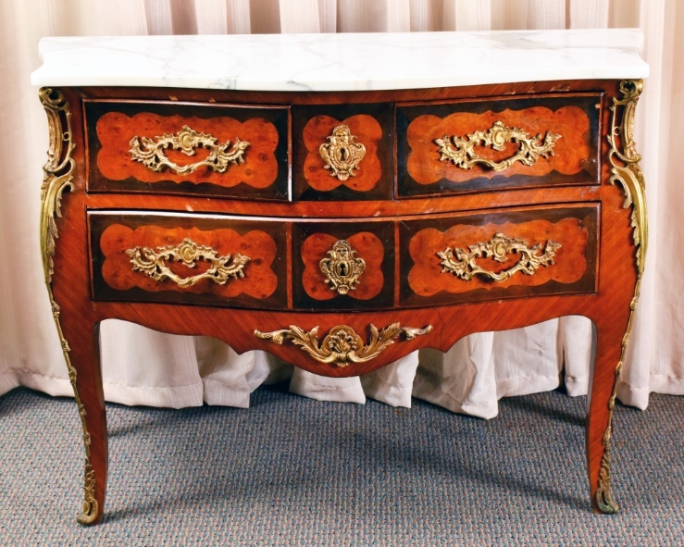
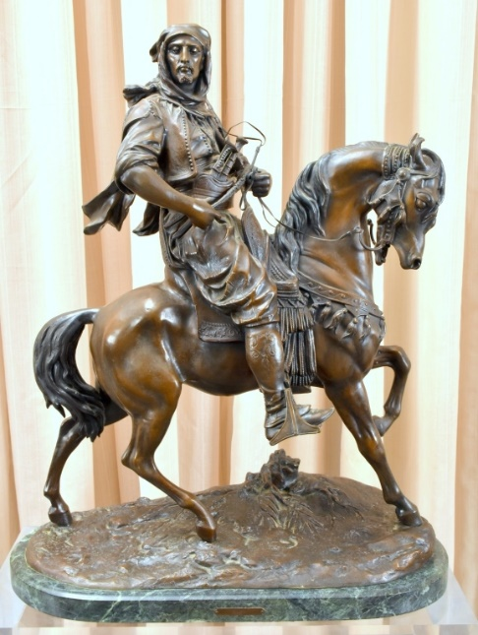
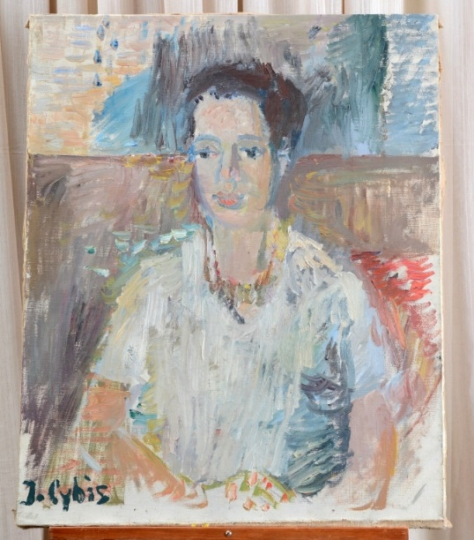
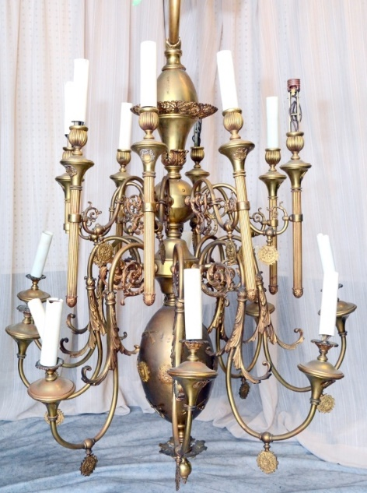

Featured Items Include:
- Barye bronze
- Antique Clocks
- louis xiv-style furniture
- Silver
- large crystal Chandeliers
- cut glass, inc. Waterford
- Porcelain & ceramics
- Lamps & MIrrors
- ornate picture frames
- orientalia
- primitives
- Artwork, Inc. Polish Artists Jan Cybis, jacek polak & mieczyslaw wejman
- and much more from an alexandria, va antique shop!
As Is, Where Is, All Sales Final. Checks/Cash/Credit Cards. Buyer's Premium, Auctioneer AU3226, AB2366, AE426.
Tax Exempt Must Present 2018 Certificate.

The Specialists of the South, Inc. 544 E. 6th Street, Panama City, FL 32401. 850-785-2577.

Questions on consigning for an auction or bidding? Contact us at auctions@sospcfl.com.
July 7, 2018 – Notable Art, French-Style Furniture & More Live & Internet Estate Auction

8 AM CST Start, Preview & Registration at 7 AM
Preview week of auction Monday to Friday, 9 AM to 4 PM
The Specialists of the South, Inc.
544 E. 6th Street • Panama City, FL 32401
Bid Online Now at www.sospcfl.com

