Primitives, Porcelains, Antiques & More Live & Internet Auction
Saturday, June 3, 2017 at 8 AM CST. Preview week of auction, Monday through Friday, 9 AM to 4 PM CST.

Bid online now at www.sospcfl.com!

The Specialists of the South
544 E. 6th Street Panama City, FL 32401
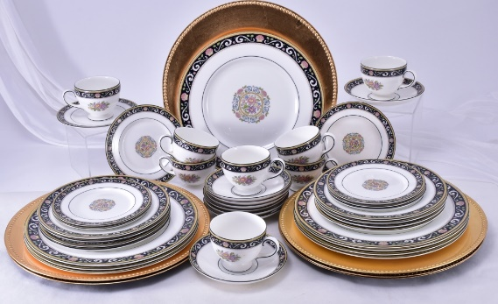
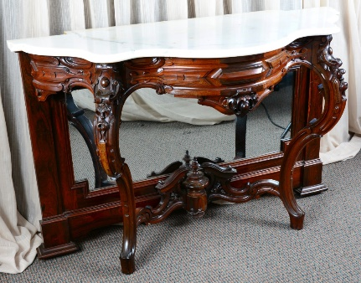
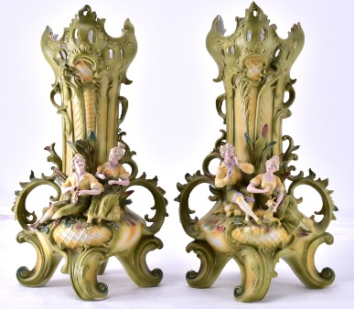
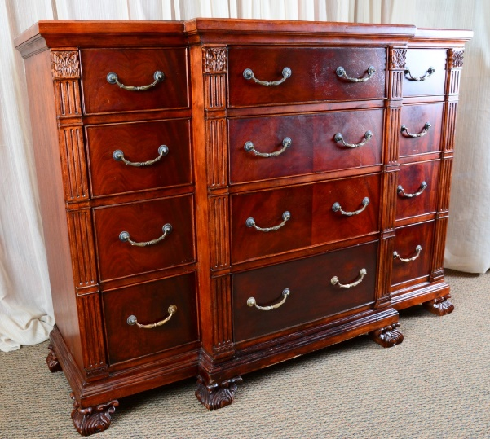
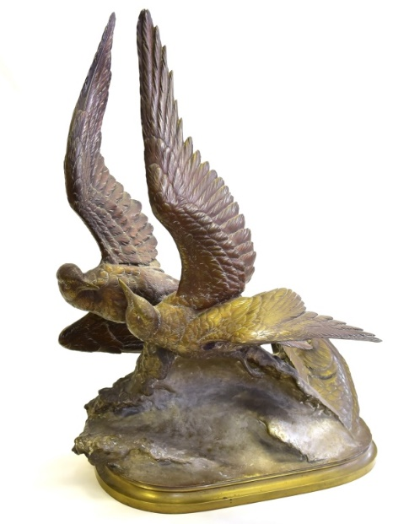
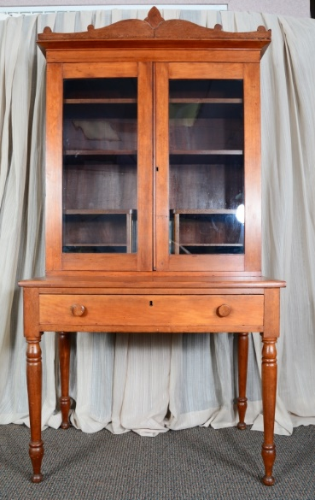
As Is, Where Is, All Sales Final. Checks/Cash/Credit Cards. Buyer's Premium, Auctioneer AU3226, AB2366, AE426.
Tax Exempt Must Present 2017 Certificate.

The Specialists of the South, Inc. 544 E. 6th Street, Panama City, FL 32401. 850-785-2577.

Questions on consigning for an auction or bidding? Contact us at auctions@sospcfl.com.

