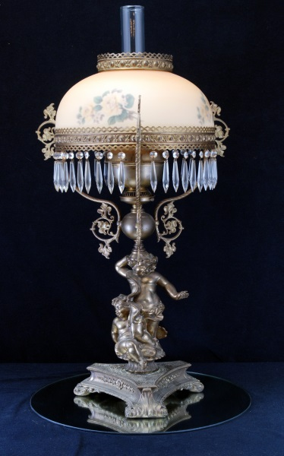
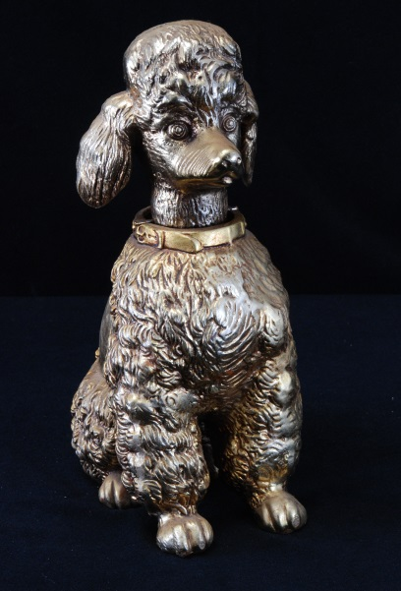
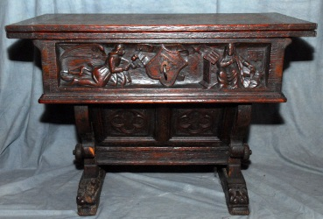
Items Include:
- Ceramics – French (Limoges), Italian (Capodimonte), German, English, Portuguese
- Large Sealife Free Form Centerpiece
- Gothic-Style Game Table
- Pool Table
- Carved & Barley Twist Desk
- Antique French Carved 85” Wide Sideboard
- Poodle Figurines in Various Sizes
- Glass (Cut, Etched, Milkglass, Knife Rests)
- Copper
- Pewter
- Hot Tub
- Art & Tapestries
- Sterling & Silverplate
- Schatz 400 day clock
- Large selection French cookware & cookbooks
- Embossed Vintage Belgian Shield w/Crossed Swords
- Brass & Crystal Chandeliers
- Impressive Banquet Lamp
- Toledo Sword
- La Jurassienne Box
- 1960s Racine Select Yachting Pocket Timer
- Baccarat Cognac Decanter
- Primitives (Cast Iron, Bed Warmer, Sieve)
- Maple Bedroom Furniture
Freeman Estate French Antiques & Collectibles
Live & Internet Auction

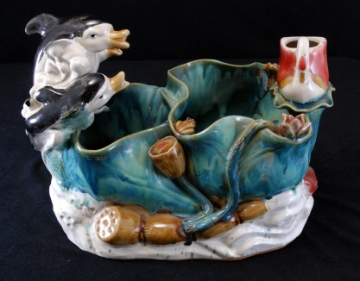
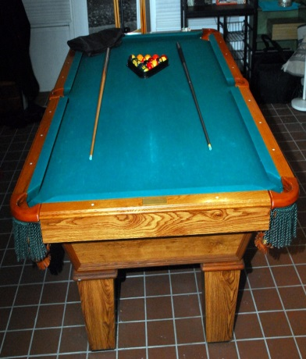
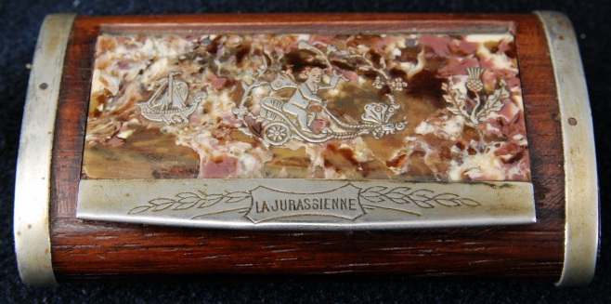
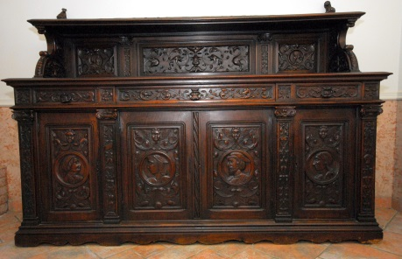
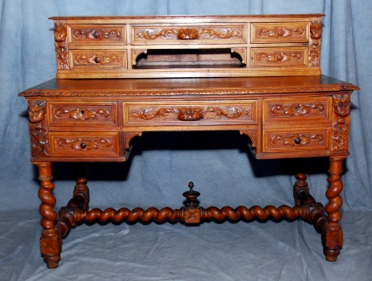

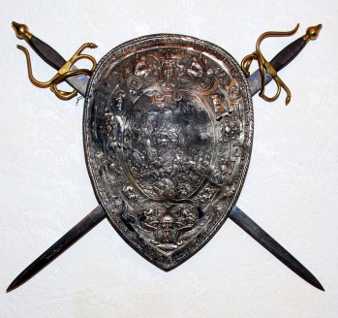
Live auction Saturday, August 29, 2015
at 8 AM CST.
Preview and registration at 7.
Internet bidding starts now at www.sospcfl.com!

This auction will be held on-site at
4801 North Lakewood Drive
Panama City, FL 32404
Live only pre-auction on Friday,
Aug. 28 at 9 AM.
As Is, Where Is, All Sales Final. Checks/Cash/Credit Cards. Buyer's Premium. Auctioneer AU3226, AB2366, AE426. Tax Exempt Must Present 2015 Certificate.
The Specialists of the South, Inc. 544 E. 6th Street
Panama City, FL 32401. 850-785-2577.

